**Exp.No:4**

a) Organize and play games to understand working of TCP/IP like: Create 2 group of students, each playing role of layers of TCP/IP (intermediate network devices roles can also be considered). Start the communication between two with a sender and receiver.

b) Determine the IP Address Configuration of a Computer (Windows) and Test the Network Interface TCP/IP Stack (Ping).

## Aim: To determine the IP Address Configuration of a Computer (Windows) and Test the Network Interface TCP/IP Stack.

**Apparatus Required (Software):** Command Prompt

## Theory:

TCP/IP is a data link protocol used on the internet to let computers and other devices send and receive data. TCP/IP stands for Transmission Control Protocol/Internet Protocol and makes it possible for devices connected to the internet to communicate with one another across networks.

### TCP/IP Model

Whenever you send something over the internet — a message, a photo, a file — the TCP/IP model divides that data into packets according to a four-layer procedure. The data first goes through these layers in one order, and then in reverse order as the data is reassembled on the receiving end.

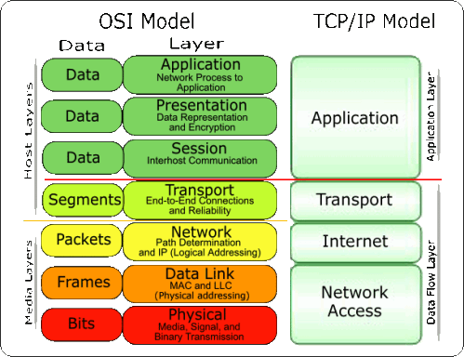

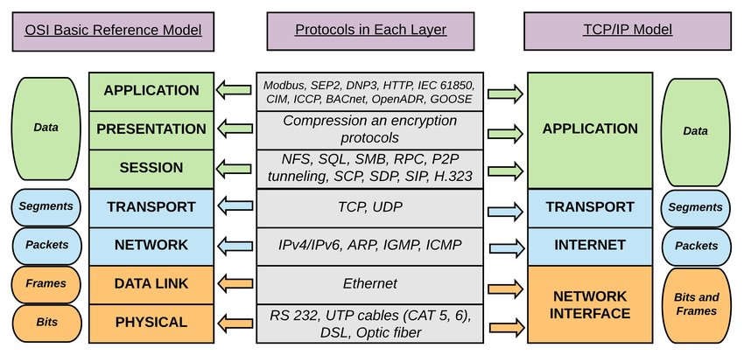

As the global standard, the TCP/IP model is one of the most efficient ways to transfer data over the internet.

### Other Common Internet Protocols

The TCP/IP model covers many internet protocols, which define how data is addressed and sent over the internet. Common internet protocols include HTTP, FTP, and SMTP, and all three are often used **in conjunction** with the TCP/IP model.

* **HTTP (Hypertext Transfer Protocol)** governs the workings of web browsers and websites.
* **FTP (File Transfer Protocol)** defines how files are sent over a network.
* **SMTP (Simple Mail Transfer Protocol)** is used to send and receive email.

**Four layers of the TCP/IP Model**

***Layer 1: Network Access Layer***

The network access layer, also known as the data link layer, **handles the physical infrastructure** that lets computers communicate with one another over the internet. This covers Ethernet cables, wireless networks, network interface cards, device drivers in your computer, and so on.

The network access layer **also includes the technical infrastructure** — such as the code that

converts digital data into transmittable signals — that makes network connection possible.

#### Layer 2: Internet Layer

The internet layer, also known as the network layer, **controls the flow and routing of traffic** to ensure data is sent speedily and accurately. This layer is also responsible for reassembling the data packet at its destination. If there’s lots of internet traffic, the internet layer may take a little longer to send a file, but there will be a smaller chance of an error corrupting that file.

#### Layer 3: Transport Layer

The transport layer **provides a reliable data connection** between two communicating devices. It’s like sending an insured package: The transport layer divides the data in packets, acknowledges the packets it has received from the sender, and ensures that the recipient acknowledges the packets it receives.

#### Layer 4: Application Layer

The application layer is the group of applications that **let the user access the network**. For most of us that means email, messaging apps, and cloud storage programs. This is what the end-user sees and interacts with when sending and receiving data.

**Find the IP Address Configuration of a Computer (Windows)**

1. Use Command Prompt to verify the PC settings and connectivity. Click Start and select Command Prompt.
2. At the prompt, enter **ipconfig /all** command to view IP configuration.

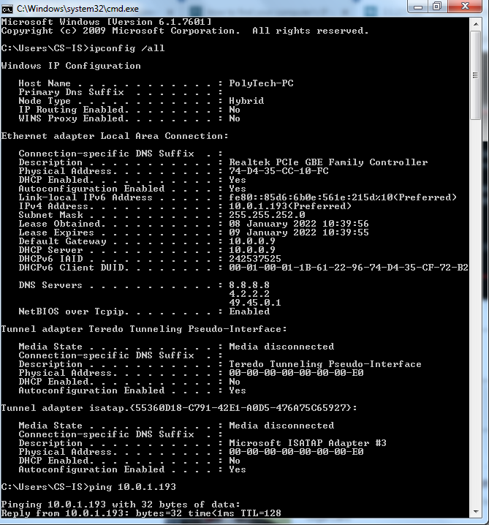

**Test the PC network interface TCP/IP stack.**

1. To verify that the TCP/IP protocol is functioning, ping your loopback address (10.0.1.193). Enter the ping 10.0.1.193 command at the prompt.  
   C:\Users\CS-IS> ping 10.0.1.193
2. You can also ping your IP address.

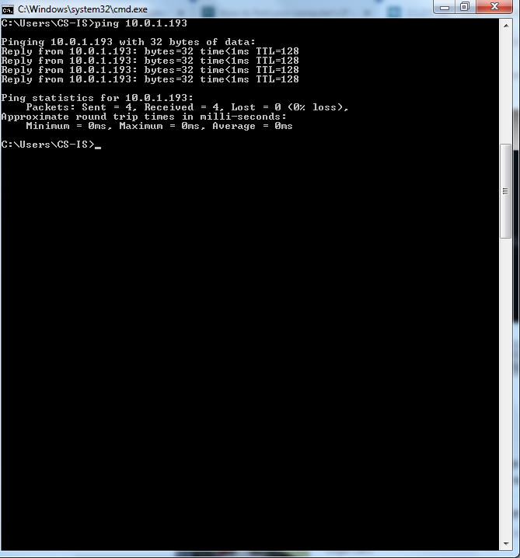

Record one of the replies from your ping command.  
Answers will vary. In this example, one of the replies was “**Reply from 10.0.1.193: bytes=32 time<1ms TTL=128**”